**CECS 262**

**LAB 4**

EXAMINING THE CALL INSTRUCTIONS

**Student Name: Khan, Umar**

**Student ID: 014477331**

**Objective:**

* To examine the call instructions.

### **Reference:**

* Mazidi and Mazidi, “The 8051 Microcontroller and Embedded Systems,” Chapter 3.

**Tasks:**

1. Modify chasingcat.a51 in the following way: write a delay function and use function call for delay. Use instruction LCALL, and put your delay function at location 0A00H. Screen shot the stack contents, SP value and PC value before the function call and before executing the first instruction in the function.

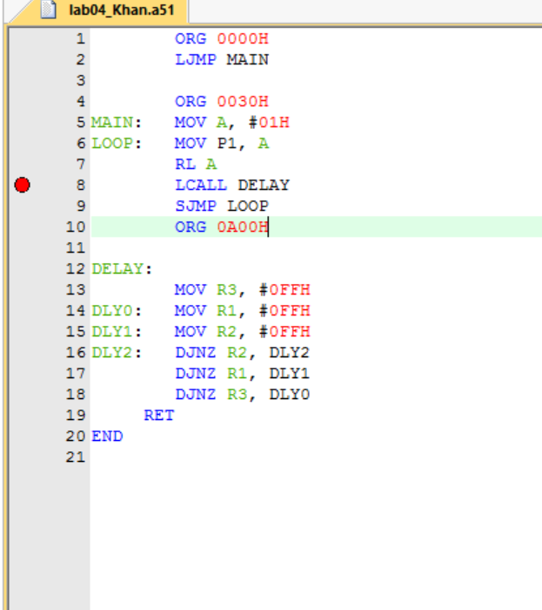

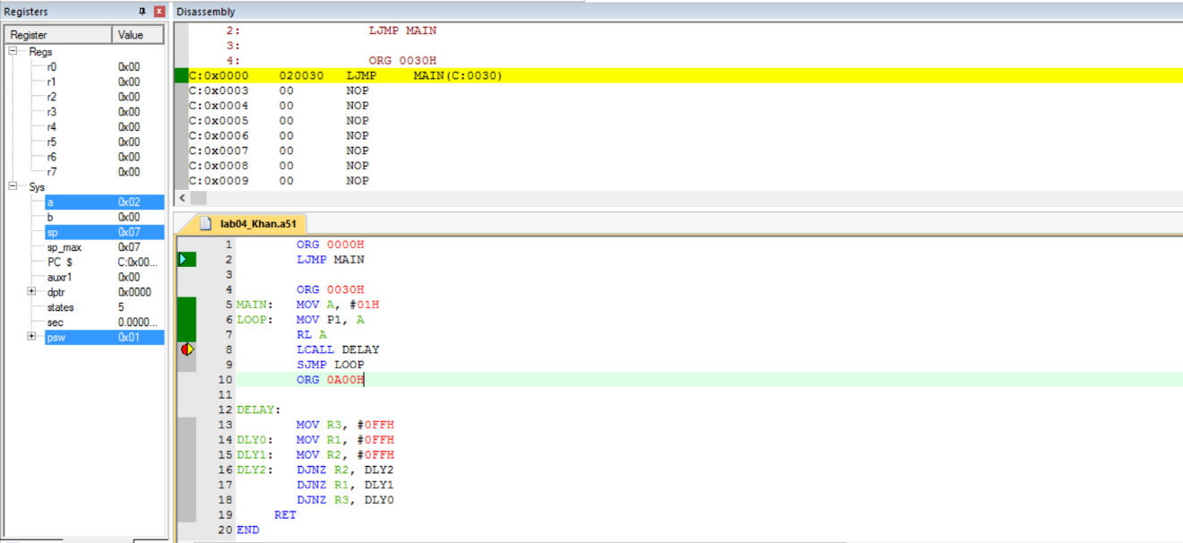

1. Modify task1 to use ACALL instead of LCALL and put your delay function immediately after you main function. Screen shot the stack contents, SP value and PC value before the function call and before executing the first instruction in the function.

